Blessed Edmund Rice Prayer

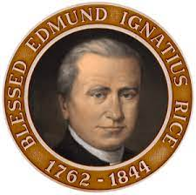

O God, we thank you for the life of Blessed Edmund Rice.
He opened his heart to Christ present in those oppressed by poverty and injustice.
May we follow his example of faith and generosity.
Grant us the courage and compassion of Blessed Edmund as we seek to live lives of love and service.
We ask this through Christ our Lord. Amen.

