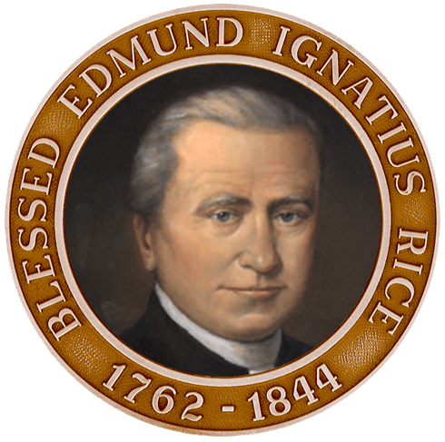
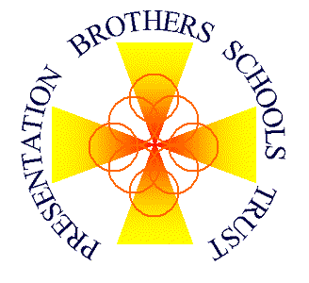

PRESENTATION BROTHERS SCHOOLS TRUST

ANNUAL REPORT

2020 - 2021

Presentation Brothers Schools Trust,
10 Deerpark Court,
Friars Walk,
Cork T12 D8H3.

ANNUAL REPORT

Background:
Presentation Brothers Schools Trust is a Company Limited by Guarantee and not having Share Capital. It was Incorporated under the Companies Act 1963 to 2006 on 7th January 2009 and was granted CHY (Charity) Status in accordance with the provisions of Section 207 and Section 266 of the Taxes Consolidation Act, 1977 and assigned the number CHY 18608.

Presentation Brothers Schools Trust was established also as an autonomous foundation in Canon Law (Canon 115.3). The Bishops of the Irish Episcopal Conference approved the Statutes of the Foundation in June 2009 thus giving it Public Juridical Person (Universitas Rerum) status.

The Company / Foundation was established in order to ensure and foster the advancement of education and further the aims and purposes of Catholic Education in the tradition of the Institute of the Presentation Brothers animated by the spirit of Blessed Edmund Rice in the eight schools operated until 2009 by the Presentation Brothers

The Company / Foundation is governed by the following:

Members: Directors:
Denis Bohane Carmel Murphy, Chair
Gene Murphy Pat Coffey, Deputy Chair
Seán Ó Caoimh TJ Coakley
Tim O’Connell Pat Hegarty
Fergal O’Gara Anna Herrick
Dáithí Ó hAodha Colm Ó Corcora
Jack O’Sullivan
Paula Sweeney

REGISTERED OFFICE
The registered Office of Presentation Brothers Schools Trust is 10, Deerpark Court, Friars Walk, Cork T12 D8H3. The Secretary of the Company and Chief Executive Officer is Michael Sexton.

SCHOOLS
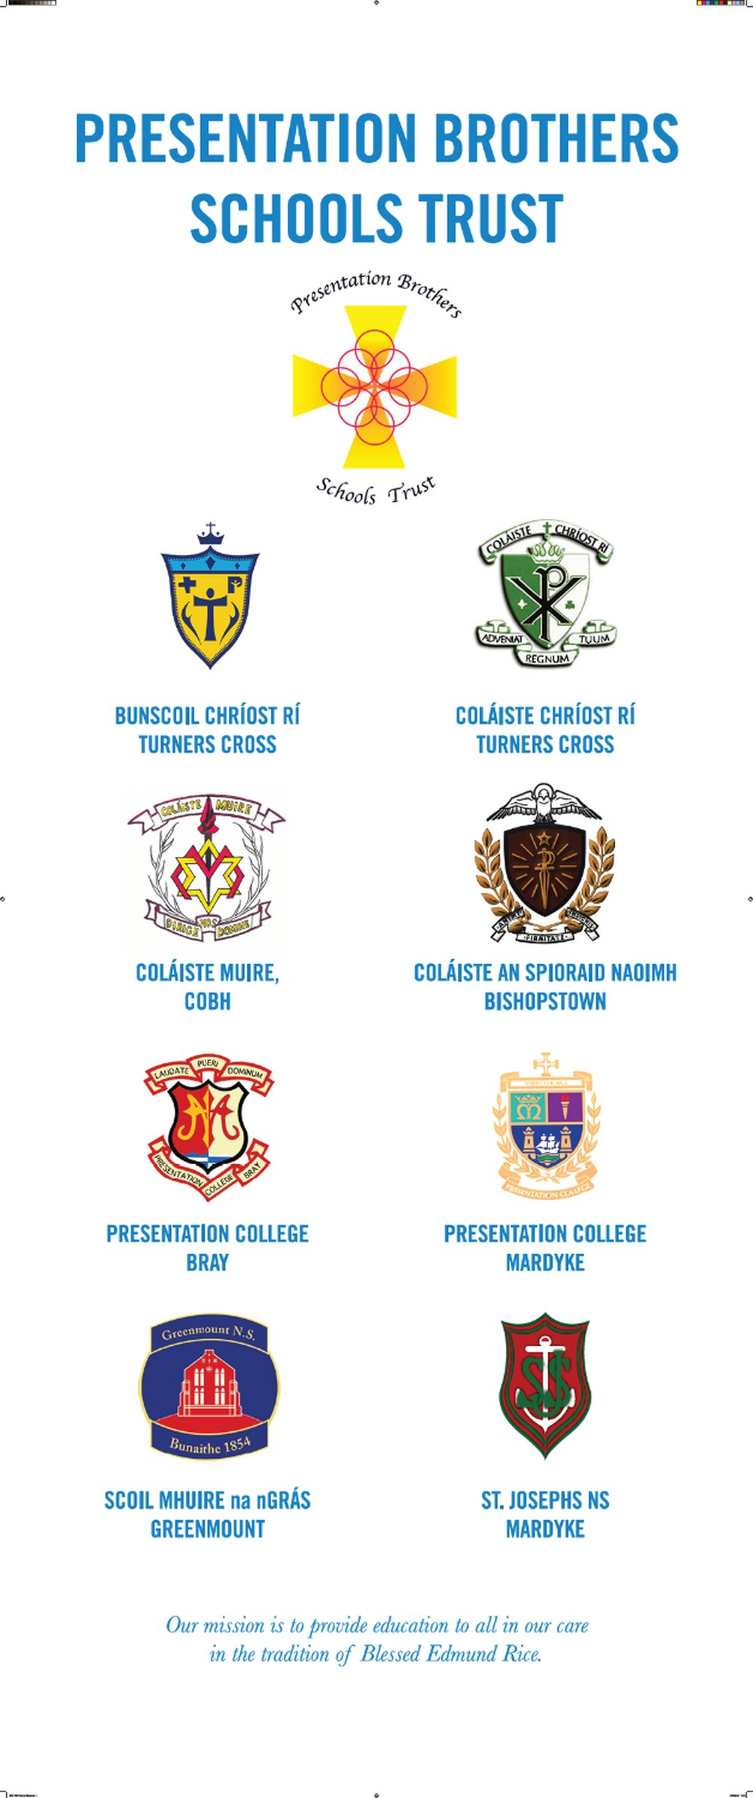
Presentation College, Bray Enrolment 647
Coláiste Chríost Rí, Cork Enrolment 546
Coláiste Muire, Cobh Enrolment 660 Co-educational
Presentation College, Cork Enrolment 717
Coláiste an Spioraid Naoimh, Cork Enrolment 713
Scoil Muire na nGrás, Greenmount Enrolment 227 Co-educational
St. Joseph’s, Mardyke, Cork Enrolment 212
Bunscoil Chríost Rí, Turners Cross, Cork Enrolment 463 Co-educational

(Enrolment numbers are as of 30th September 2020).

INDEPENDENT AUDITOR

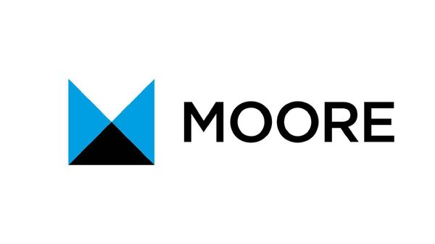
The firm, Moore, 83 South Mall Cork was re-appointed as Independent Auditor of the Foundation and the Company at the AGM held on 21st August 2020.

BANK
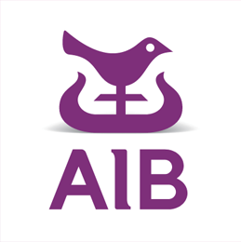
The current account for the company is held at AIB, 66 South Mall, Cork.

INVESTMENTS

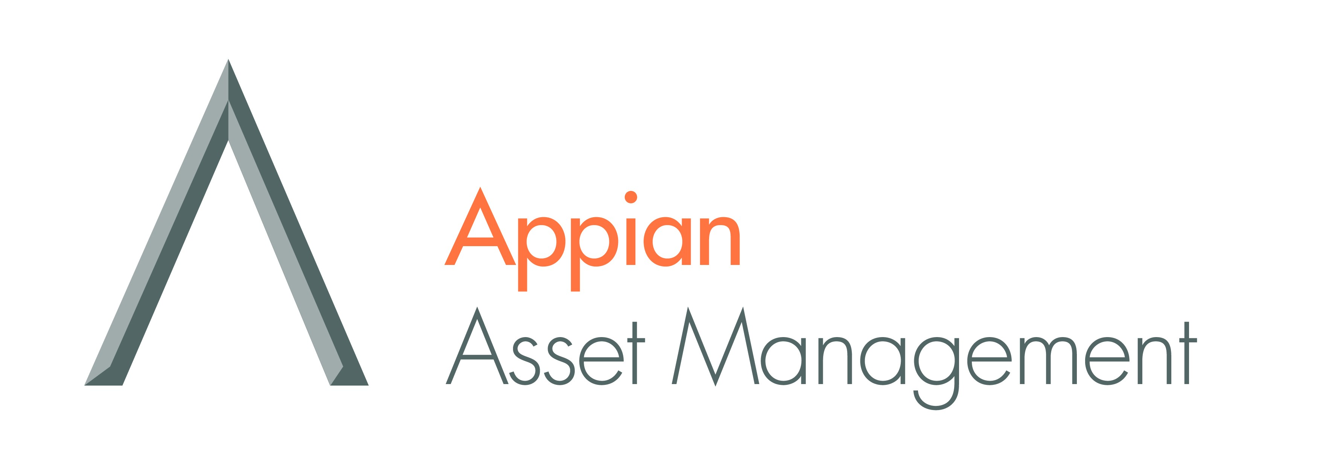

Investments accounts during the year covered by the report were held with:
Appian Asset Management Limited
Quilter Cheviot Investment Management
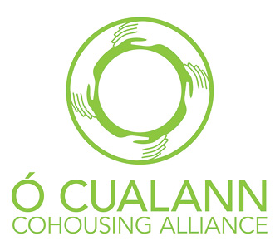
A loan was (which has since been repaid) was also provided to O Cualann Co-housing Alliance, an affordable housing co-operative.

SOLICITORS

O’Flynn Exhams, 58 South Mall, Cork.

Resignations / Appointments:

Board of Directors of PBST:
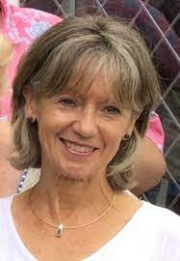
The Board of Directors remains as constituted at the Annual General Meeting held on 21st August 2020 though with Carmel Murphy taking over the role of Chairperson and Colm Ó Corcora reverting to the role of director. A resolution will be placed before the members at the 2021 AGM recommending the appointment of Pat Hegarty as Deputy Chairperson. A resolution will also be placed before the members at the AGM recommending the appointment of David O’Kelly and Jennifer Buckley as Directors (replacing TJ Coakley and Pat Coffey who will step down having served two terms on the Board).

Members of PBST:
Daithi Ó hAodha was appointed a Member at the Annual General Meeting held on 21st August 2020. The membership remains as constituted following that meeting. A resolution will be placed before the Members at the 2021 AGM suggesting the appointment of TJ Coakley and Pat Coffey as Members with effect from 20th August 2021. Fergal O’Gara and Gene Murphy will be required to step down having served two terms as Members.

Chief Executive Officer of PBST:

The position of Chief Executive Officer of the trust has been occupied since September 2016 by Michael Sexton who has been seconded to the trust on a year-by-year basis from his position as Principal of Coláiste an Spioraid Naoimh. As secondment from a DES-paid position to a trust body cannot extend beyond five years, the Board of Directors has offered a five year contract to Mr Sexton (commencing on 1st September 2021) which he has accepted. This will see Mr Sexton retiring from his position in CSN and becoming an employee of the company.

Meetings of Board of Directors:
Thirteen meetings of the Board of Directors were held since the Annual General Meeting on 21st August 2021. Five meetings were held in person (socially distanced at various school locations or, on one occasion, at the trust offices) with all others meetings held remotely owing to the pandemic. Attendance by the Directors was extremely high with full attendance at almost every meeting.
Boards of Management:

A new Board of Management was appointed by PBST in October 2020 at Presentation Brothers College, Cork (with Jack O’Sullivan as Chairperson). New Board are to be appointed in October 2021 at Coláiste an Spioraid Naoimh, Colaiste Chríost Rí and Presentation College, Bray.

Appointments to School Leadership positions:


Ms Brenda Moriarty has been appointed Principal of Coláiste an Spioraid Naoimh with effect from 31st August 2021 as a consequence of the decision of Mr Michael Sexton to retire as of that date. Mr Philip O’Sullivan has been appointed Deputy Principal of Coláiste an Spioraid Naoimh with effect from 31st August 2021 as a consequence of Ms Moriarty’s promotion from Deputy Principal to Principal.

Mr Martin Locke, was appointed Principal of Presentation College, Bray on 1st September 2020, following the retirement of Mr Pat Gregory. Mr Ger Fleming was appointed to replace Mr Locke as Deputy Principal as of the same date.

Mr Liam Shorten was appointed Deputy Principal of Coláiste Chríost Rí on 1st September 2020, following the retirement of Mr Dáithí Ó hAodha.

Ms Ailín O’Donoghue was appointed Deputy Principal of Presentation Brothers College, Cork on 1st September 2020 following the resignation of Ms Marian Carey (who had been appointed Principal at another school).

Ms Doirín Sheehan is currently acting up as Principal in St Joseph’s N.S. as Ms Roseanne Neville is on maternity leave.

Regulatory and Financial Matters

Constitution / Memorandum and Articles of Association:


No amendments were made to the Constitution / Memorandum and Articles of Association of Presentation Brothers Schools Trust during the year governed by this report.

Licence Fees:
The annual Licence Fee of €6 per student was paid by each of the four non fee-paying second-level schools and a letter of acknowledgement issued to each Board of Management in respect of same. The terms of the Management Licence Agreement for Presentation Brothers College was temporarily amended (resulting in a reduced payment) with the approval of the Presentation Brothers.

PBST Accounts: Monthly accounts were presented by the CEO at each meeting of the Board of Directors. Audited accounts were prepared by Moore and will be formally approved by the Board at its meeting to be held on 20th August 2021. They will be presented to the Members of the Company at the AGM to be held on 20th August 2021.


Schools’ Accounts:
Each second-level school presented a draft budget for approval by PBST for the 2021-22 school year. All schools presented Statements of Accounts prepared by an external accountant for the school year ending 31st August 2020 which were approved by the PBST Board of Directors. In the case of PBC, an audit was carried out by Moore which was approved by PBST. Copies of all second level schools’ accounts were forwarded to the Irish Episcopal Commission and to the Financial Support Services Unit of the JMB. To ensure greater consistency of approach, all eight PBST schools have, for the last two years, had their accounts prepared by the same firm of accountants (Moore).

Companies Registration Office (CRO):
Form B1 (annual return) was submitted to the Companies Registration Office. The change of Chairperson of the Board of Directors made at the AGM held on 21st august 2020 was registered with the Companies Registration Office.

Legal Entity Identifier (LEI) registration:
PBST applied for and were provided with an LEI code valid until 25th September 2025 enabling the trust to trade financial instruments (e.g. stocks, bonds, currencies, etc.) using a broker licensed by an EU state.

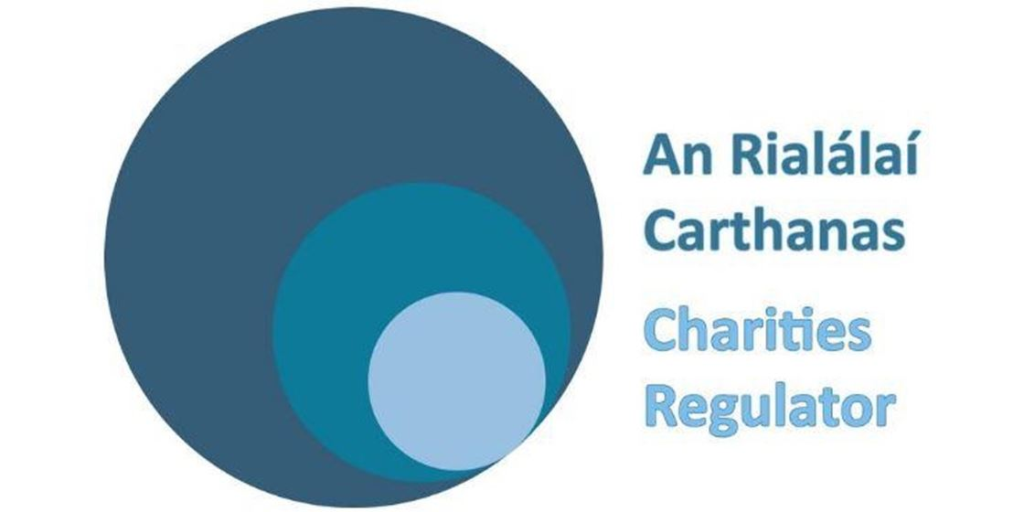
Charity Regulatory Authority (CRA):
In accordance with the requirements of the CRA, Presentation Brothers Schools Trust became registered under the Charities Act 2009 and was given Charities Regulatory Authority number 20071721 and Registered Charity number 20005085. Changes to the Board of Directors made at the AGM held on 21st June 202 were registered with the CRA on 24th November 2020. An annual report (including audited accounts) for Presentation Brothers Schools Trust for the reporting period ending 31st January 2020 was submitted on the 21st October 2020.

Charities Governance Code:
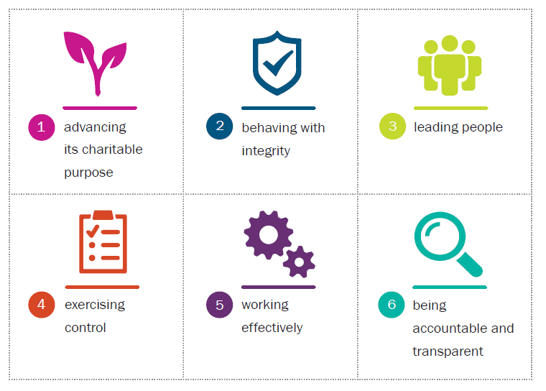
As all registered charities are, with effect from 2020, obliged to complete a Charities Governance Code Compliance Record Form each year, the Board of Directors completed its work during the course 2020-21 on determining ‘core standards’ for the trust and in drawing up key compliance documents for each of the six principles established by the Charities Regulator. This was a significant undertaking for the Board and took up considerable time at Board meetings over the last 18 months.

Principle 1: Advancing Charitable Purpose
Core standards plus:
Annual budget template
PBST Trustee Functions document
PBST Reserves Policy

Principle 2: Behaving with Integrity
Core standards plus:

Register of PBST Directors’ Interests
PBST Conflict of Interest Policy
Code of Conduct for PBST Trustees
Code of Conduct for PBST Employees

Principle 3: Leading People
Core standards plus:
Role of the PBST Chairperson document
Role of the PBST Secretary document
PBST Process for Induction of new Employees

Principle 4: Exercising Control
Core standards plus:
PBST Risk Management Policy
PBST Risk Register

Principle 5: Working Effectively
Core standards plus:
PBST Induction Process for New Trustees
Declaration to be made by a proposed
PBST trustee (director)

Principle 6: Being accountable
Core standards plus:
PBST Communications Policy

The Reserves Policy was developed during the course of the year to further complement policies developed last year under Principal 1 (Advancing Charitable Purpose). As the Compliance Record Form must be made available to the Charities Regulator for inspection from 2021 onwards, the Board of Directors will review and, where necessary, update the Compliance Record Form and accompanying documentary evidence (including all policies) on an annual basis and have them available for inspection as required. The whole area of compliance has become a significant but unavoidable burden for the Board in recent years and is an area that is likely to see further regulation in years to come. Much of the impetus for increased regulation has been driven by a lack of Board oversight that has enabled fraudulent activities on the part of senior management at a few high-profile charities. PBST is confident that the core standards (and accompanying policies) that have now been drawn up for the trust should ensure that, provided the Board continues to exercise a high level of oversight, the trust now has a very high standard of practice in this area.

Insurance:

A review of the Custodian School Protection Policy for PBST and for all PBST schools was carried out and terms agreed with O’ Leary Insurance Group prior to the renewal date of 25th March 2021. Insurance policies for all eight schools and for the Trust’s offices were renewed for the year as of that date. A cyber insurance policy with CFC Underwriting was renewed prior to the same renewal date through O’Leary Insurance Group to cover PBST schools against cyber crime, ransomware, data loss etc.

Child Safeguarding and Risk Assessment :

In accordance with the Children First Act 2015, Children First: National Guidance for the Protection and Welfare of Children 2017, the Child Protection Procedures for Primary and Post Primary Schools 2017 and Tusla Guidance on the preparation of Child Safeguarding Statements, Child Safeguarding and Risk Assessment Statements (which had been reviewed by each Board of Management during the 2020-21 school year) were received from all schools.

Admissions Policies:
In accordance with the provisions of the Admissions to Schools Act (2018), the five second-level schools submitted draft Admissions Policies to PBST and, following review by the Board, the policies were approved by PBST as patron of these schools. All schools included the standardised definition of a Catholic school as recommended by the Irish Episcopal Conference and the standardised wording on the Religious Education ‘opt-out’.

As the Bishop is the patron of the three PBST Primary schools, the Boards of Management of these schools do not submit their policies for PBST approval. PBST did, however, review the primary schools’ draft policies when requested to do so prior to their submission to the patron.

Use of school premises:

All schools are required to inform the Trust of the use of the school premises by outside bodies (regardless of whether or not a payment is made). An Application Form for the Use of School Premises on which details of all proposed hire and use arrangements are recorded was provided to each school and a new, more simplified system has been put in place for the return of the form to PBST and the issuing of a licence. Owing to the pandemic, most schools provided limited or, in some cases, no access to school facilities by outside bodies during the course of the school year just completed. All schools have been reminded of the vital importance of ensuring that all bodies using school premises are fully ensured and that proof is provided of such insurance to the Board of Management.

Credit Cards:
As the FSSU has advised that the use of credit cards in schools is subject to trustee approval, approval has been granted to the Boards of Management of six of the schools. A record of all applications is kept on file.


Investments: As stated in last year’s report, all of the trust’s long-tem, high-yielding investments have matured over the course of the last few years, leaving the trust with large reserves of cash. The Board, therefore, spent a considerable amount of time over the last while examining other investment options, setting up a sub-committee to evaluate investment products and reporting back to Board meetings. As Members will, no doubt, be aware, interest rates are currently at an all-time low with many banks either offering 0% interest or negative interest on monies held on deposit. Given the impact of inflation, retaining money on deposit would, in effect, result in the trust’s funds losing value. As this would hardly be a prudent management of the trust’s resources, the Board decided to invest a total of €1,050,000 in three separate, low to medium-risk products over a medium to long-term (5 to 10 year period). The first of these is with Quilter Cheviot, a well-established international asset management firm that specialises in charities’ investments. The €350,000 is currently* valued at €395,078. The second investment is with Appian Asset Management, a Dublin-based, investments firm which seeks out what are described as value stocks (avoiding what they believe are over-valued big-brand stocks). Our €350,000 investment with Appian (divided evenly between two funds) has a current* value of €422,400. Out third investment is with AIB/Irish Life, a long-established Irish company that might be seen as offering a more conservative approach to investment. Our €350,000 investment with AIB/Irish Life has a current value of €368,368 (as of 26th July 2021). In making these investments, our strategy has been to ensure diversification by placing an equal amount of money with separate firms taking somewhat different approaches. We have also taken steps to ensure that our investments are ethical and responsible.
*Current as of the end of Q2 (31st June 2021). Initial investment took place in late 2020 / early 2021
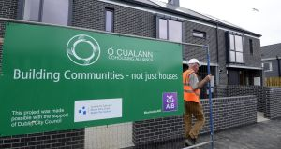
As also stated in last year’s report, the Board took a decision to issue a €1m loan to O Cualann Co-housing Alliance, a not-for-profit housing alliance, as the interest rate offered was attractive (4%) and the risk was adjudged to be low. This risk assessment was based on the fact that no other lending agency (such as a bank) which might have a prior call on the repayment of borrowings was involved in the project and that PBST was granted a mortgage on the site as security for the loan. It was also felt that the not-for-profit and community-based approach adopted by this particular enterprise fitted in well with the ethical approach to investment that had been adopted by the Board as a key consideration in our long-term investment strategy. It was initially envisaged that this project, which involved the construction of 37 affordable homes at Oileáin na Cronnóige, Ballymum, would take 12 months to complete. Owing to Covid-19 site closures however, this project has extended over nearly two years – something that has worked in our favour as interest continued to be paid. The full €1m has now been repaid, yielding a total of €69,583 in interest over the 21 months.
In view of the successful outcome of this arrangement, consideration is currently being given by the Board to the funding of an extension to the Ballymun scheme which would see a new loan of €1m (possibly up to €1.25m) issued to O Cualann over a shorter period (perhaps 9 to 12 months). We have built up a very positive relationship with this organisation over the last two years and we feel that there is a good match between the aims of O Cualann and PBST’s charitable purpose. We are therefore confident that, over the longer term, (presuming a successful outcome to the Ballymun extension project), we might become a recurring funder of smaller O Cualann projects. In any such arrangement, we would continue to insist on having ‘first call’ on the repayment of borrowings and that we would be provided with a mortgage on the site which would be of higher value than the size of the loan. O Cualann are currently in negotiations with Cork City Council for a small scheme on the northside of Cork City and we would be hopeful that this may be another more locally-based project for which we may provide funding in due course.
Property:

Bunscoil Chríost Rí:
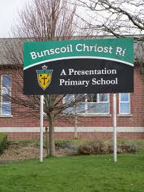
No major additions were made to the premises during the current year. There were, however, a number of insurance claims arising out of storm damage to roofs and railings. The Presentation Sisters continue to state that it is their intention to sign over full ownership of the former girls’ school building to PBST, replacing the existing 999 year lease. Discussions between the congregation and the DES appear to have stalled over the course of the last year but we have recently been informed that a conclusion to these discussions is imminent.

St Joseph’s National School
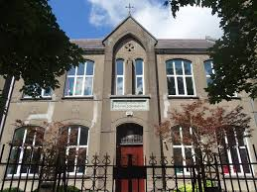
The construction of a four classroom extension for which DES funding has been secured under the Additional Accommodation Scheme is currently at the design stage. The design will incorporate two ground-floor SEN rooms and various ancillary rooms in a two-storey building. Both the Board of Management and the Trust are very pleased that this long-overdue upgrade of the school premises is moving towards the construction stage. Separately, external sheds in the school yard were converted into a toilet block during the year, adding enhanced sanitation facilities during the pandemic. The Board has also received an Emergency Works grant for the replacement of cast iron gutters and the re-rendering of external plasterwork.

Scoil Muire na nGrás, Greenmount NS:
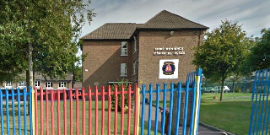
The Board of Management is currently at the pre-planning stage on a new building which will accommodate two new classrooms and ancillary rooms for pupils with special education needs. This building, which is designed in a contemporary style, will be located on the Green Street side of the school and will link to the existing school building. All going well, the Board will apply for planning in September and it is hoped that construction will commence in spring or summer 2022. A grant has also been received under the Emergency Works Scheme for the repair of concrete valleys on the roof. A major upgrade to the school’s electricity switch board also took place during the year.
Coláiste an Spioraid Naoimh:
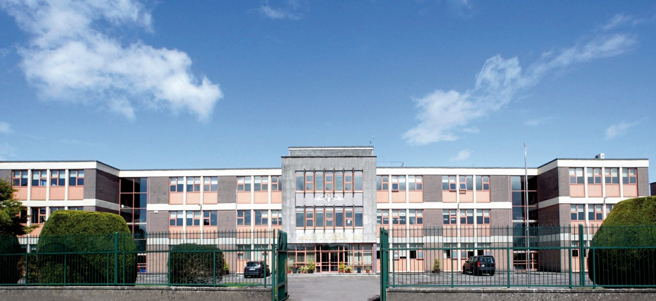
The Board has recently received DES approval for a very extensive expansion under the Additional School Accommodation Scheme. This project will include provision of three mainstream classrooms, an art room, a multi-media room, a music room , a DCG Room, two science labs and two construction rooms. A two classroom SEN base will also be provided. These facilities will, in all probability, be provided in a building separate to (or perhaps adjoining) the existing school building.

Coláiste Chríost Ri:
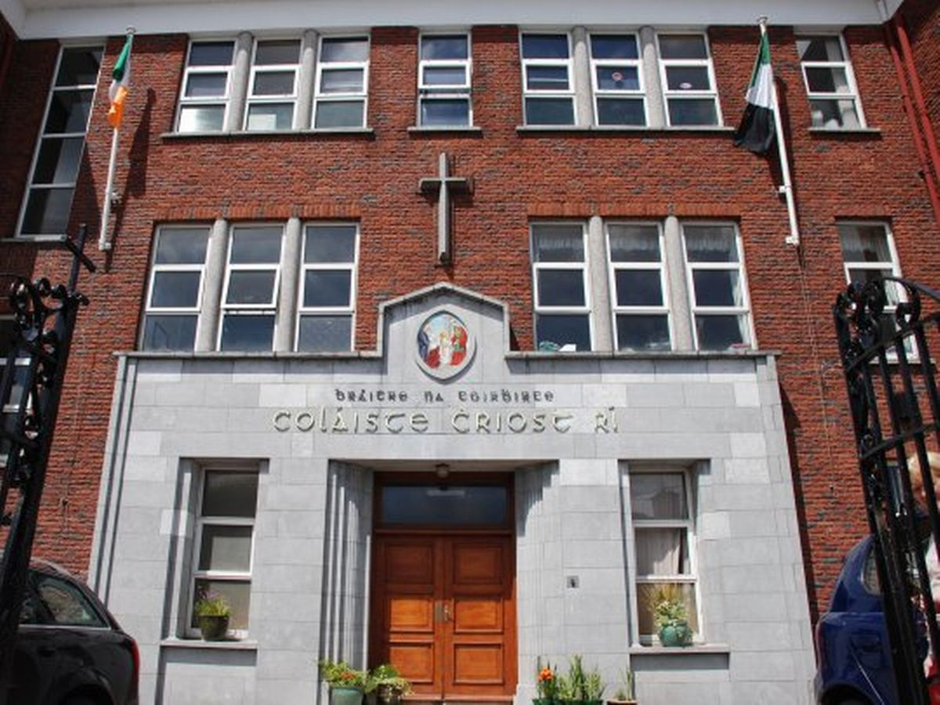
Following approval received in December 2020 for the setting up of a Special (ASD) Class, the school received the go-ahead to procure a 100 m² modular building – with a view to the Special Class opening in August 2021. The school subsequently received a further letter from the DES Schools Capital Appraisals Section giving approval for much bigger project to include a DCG room, an art room, a music room, a construction room, project storage rooms, and a suite of SEN rooms to accommodate the ASD Special Class on a permanent basis.

Coláiste Muire, Cobh:
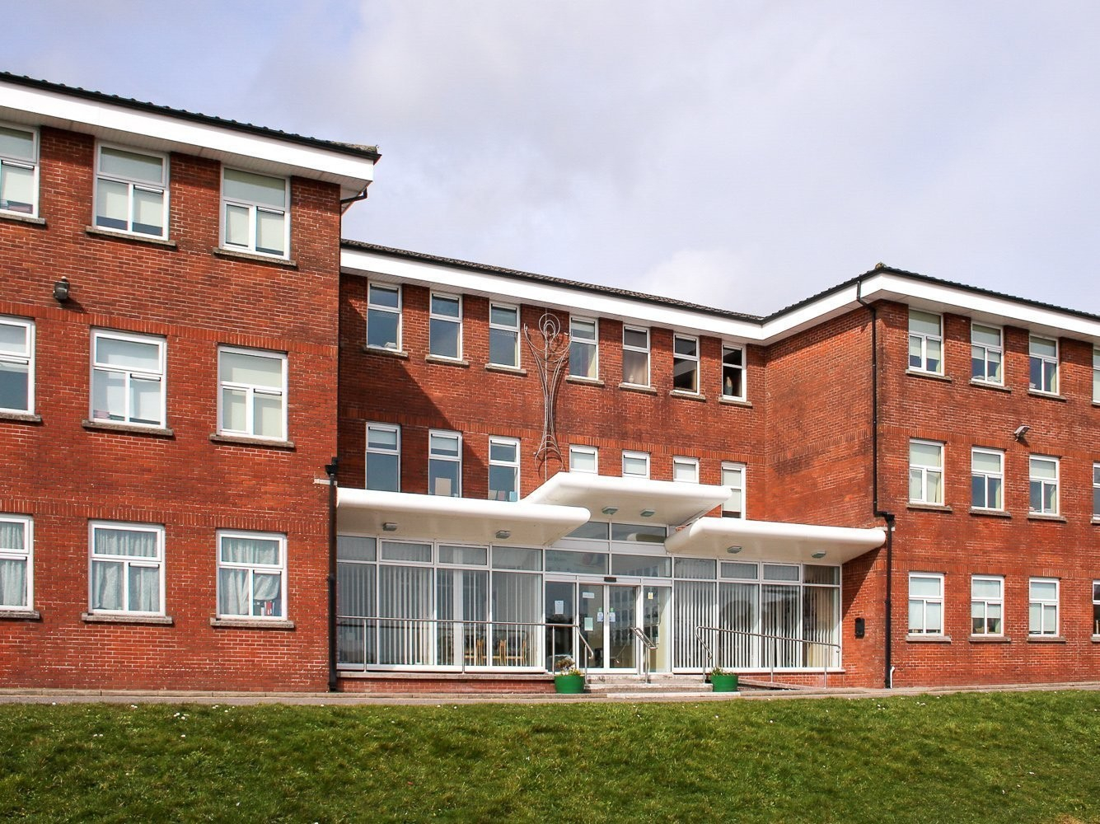
DES approval was received in January 2021 for the replacement of four 1970s prefabs and two modular rooms. This was followed by a letter received in April for the provision of nine general classrooms (to replace the prefabs and modular rooms), a music room, a DCG room, a science lab/prep area, an Art room, a project store, a two-classroom SEN base and four SET (learning support) rooms. This project will involve the construction of 2100m² of new buildings to replace the 300m² of old prefabs.

Presentation Brothers College, Cork:
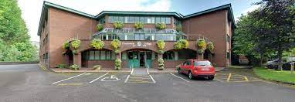
The Board of Management continues to work on a plan for the major enhancement of facilities at both the Mardyke and Wilton. Much of this will focus on the need to upgrade sports facilities at the Mardykle campus to accommodate the provision of Leaving Certificate PE. The plans also are likely to also entail an upgrade of student common area facilities within the existing school building. Extensive water damage to floors was caused by a burst pipe in February. This resulted in an insurance claim of some €150,000. While some repairs were carried out immediately, the bulk of the repair is to be carried out during the summer holidays when there will be less disruption to school life.

Presentation College, Bray:
No further progress has been reported on the rectification of defects in the design and/or construction of the new sports hall that have become apparent. These defects have resulted in leaks from the roof that have caused damage to the wooden floor.
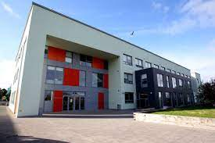
Negotiations are at an advanced stage between the Presentation Brothers and a local landowner whose property adjoins the school. In return for the Brothers relinquishing ownership of a section of roadway they currently own and PBST extinguishing its lease of a sliver of ground parallel to the roadway, a developer (who is to buy the land adjoining the school from the landowner) will provide the a much-enhanced road and cycleway, turning circle and parking on that section of roadway which will be retained by the Brothers. It is understood that, once the project has been completed, it is the Brothers’ intention to extend the existing PBST lease on the school to also include that section of roadway (the Newcourt Road end) that is being re-developed. A condition of the planning permission that has been granted is that the developer will also provide a separate cycleway, accessible to the public, along the length of the roadway. The developer has further agreed to provide a drainage channel which, it is hoped, will solve a long-standing drainage issue where run-off from the school’s sportsfield is causing water-logging in neighbours’ gardens. At the time of writing, negotiations are at something of an impasse as the Brothers are asking for a bond (or similar) to cover the costs of the works during construction.

General
All schools had to make accommodations to meet the demands of the pandemic. In some cases this was a significant challenge for school managements, involving everything from the repurposing of rooms to the provision of additional toilet facilities and the conversion of PE halls into classrooms. More positively, the granting of something in the region of €20m worth of new building projects to our schools is extremely welcome news and a tribute to the Boards of Management who have had to work hard to secure these awards. The hope is that these projects don’t get mired in protracted planning processes that could slow things up for several years. On a very different matter, some four years after its submission, the Trust still awaits a response from Cork City Council/OPW to its submission on the Lower Lee Flood Relief Scheme – a scheme that, if implemented as currently proposed, would have profound implications for PBST-owned properties at Presentation Brothers College and St Joseph’s NS.

Chaplaincy:

Presentation Brothers no longer serve as chaplains in any of the PBST schools. A part-time lay chaplain is employed in Presentation Brothers College, Cork but, unfortunately, the part-time lay chaplain in Coláiste Chríost Rí left to take up a position elsewhere. Brother Martin who serves as a member of the Board of Management in Coláiste Chríost Rí does, however, provide ongoing support both in that school and in Coláiste an Spioraid Naoimh. A number of local clergy and a Christian Brother (Brother Ben Cusack) continue to fulfil unofficial chaplaincy roles in other schools.

Links with the Congregation of Presentation Brothers and the wider Presentation Family:
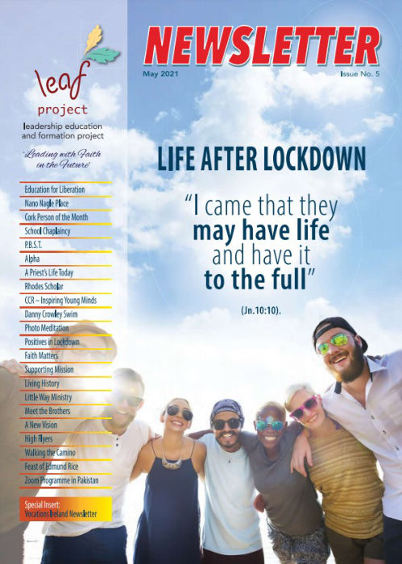
PBST cherishes its origins in the Congregation of Presentation Brothers and takes very seriously the solemn assurances it gave to the Congregation that the four core elements of a Presentation education, as outlined in our Charter, will be upheld and promoted. Informal meetings between members of the Congregation’s leadership teams and PBST take place from time to time. The Presentation Brothers’ Leadership, Education and Formation Project (LEAF) continues to go from strength to strength and Brother Martin has been very active in many of the schools. Brother Martin has also provided video inputs for significant days in the Presentation calendar. PBST has contributed articles to the LEAF magazine that is published periodically and distributed widely both online and in hard copy. Activities with an ethos dimension that take place in the schools are also featured in the magazine. Both Brother Martin and Dr Frank Steele delivered inputs at the PBST-organised on-line seminar for members of Boards of Management.
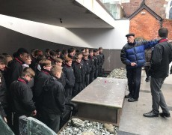
Each month, school leaders also receive a copy of Dr Steele’s Lux Edmundi essay – a reflection that never fails to offer a thought-provoking perspective on the challenges of providing an authentic Catholic education in an increasingly secularised world. Unfortunately, owing to the pandemic, it was not possible for students to involve themselves in many activities (such as Share and Edmund Rice Action camps) that are synonymous with the Presentation tradition.

Implementation of PBST Strategic Development Plan (2015-2020)
The current five year cycle for the implementation of the trust’s strategic development plan as drawn up by Jack O’Sullivan (former Chairman), Paul Scanlan (former CEO) and Luke Monahan (consultant) came to an end in 2020. The intention had been to review the work of the trust and the implementation of the plan in 2020 in accordance Article 60 of the Company’s Articles of Association. The impact of Covid-19 made this impossible of course so, as reported last year, it was decided to postpone the review and to continue the implementation of the existing plan for an extra year. Owing to the ongoing pandemic, the year just gone was, however, probably the least productive of the six years in terms of the implementation of the plan. While some activities did move on-line, most of the headline events simply couldn’t take place. This was disappointing as it meant that the review was conducted at the end of a rather quiet year.

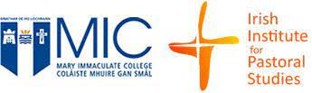
Sixteen teachers from five PBST schools did, however, enrol in the Mary Immaculate College (Limerick) programme in School Ministry and Liturgy Preparation. This was an on-line programme administered by our colleagues in the Edmund Rice Schools Trust that ran over five evenings from late January to early March. Programme fees were jointly paid by PBST and the participants’ Board of Management. Feedback from the participating teachers was extremely positive.


While the PBST Leadership Development Programme could not run this year, it is now well established and continues to attract interest from significant numbers of teachers. Over sixty teachers from the eight schools have now completed one or other of the two programmes offered. Going forward, the trust will continue to offer the programmes in alternate years to aspiring senior leaders (Programme 1) and to aspiring middle leaders (Programme 2). Feedback from participants on these programmes has been very positive. A key feature of both programmes is the linking of the six leadership themes to the competency-based interview model and to the PBST Charter. This ensures that the training of our future leaders is grounded in the underpinning, faith-based principles of a Presentation education as laid out in the PBST Charter.

Similarly, the annual conference for PBST senior school leaders (Principals, Deputy Principals and Board Chairpersons) and trust directors which has become a fixture on the calendar was also a Covid-casualty. Several online meetings of Principals did take place however as particular issues arose. Other casualties were the seminar for new staff members and the student-leader seminar.

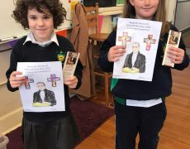
The regular meetings of RE co-ordinators did continue, though these moved on-line making use of the Zoom platform. These meetings are now well-established as a forum for the expression of views on ethos-related issues and also for the dissemination of news between the trust and the schools and among the schools themselves. Brother Kevin Mascarenhas participated in one of these meetings to encourage PBST schools to become involved in the Schools of Sanctuary programme. Two of the schools subsequently expressed an interest in participating – though, in both cases, it wouldn’t be until next year (when, it was hoped, the Covid situation would have improved).

The annual Board of Management seminar also took place on-line in early May. This year, the chosen theme of the seminar was ‘Nurturing the Presentation Ethos of Our School’ and it was attended by nearly 50 Board members from the various schools. Presentation were given by Brother Martin Kenneally (on ‘what it means to be a Catholic School today’), by Dr Frank Steele (on ‘ the origins and history of the Presentation tradition’) and by the CEO (on ‘the roles of the trust and the board of management in ethos promotion’). The event was chaired by trust Chairperson, Carmel Murphy.
5 Year Company Review:

As stated in the previous paragraph, the directors of the trust are obliged (in accordance with Article 60 of the Company’s Articles of Association) to conduct a review of the company’s affairs every five years. Dr Margaret O’Donovan, was therefore engaged by the trust to conduct an independent review to be presented at this year’s Annual General Meeting (the review having been deferred last year). The mechanism for conducting the review was agreed between the directors and Dr O’Donovan in advance and a programme to facilitate consultation with all stakeholders was set out. This involved face to face discussions with senior leadership teams in schools and with student representatives in second-level schools. It also involved on-line meetings with Boards of Managements and with parents’ councils where such existed. All staff members (both teaching and non-teaching staff) in PBST schools were invited to complete a comprehensive on-line questionnaire. Well over 200 staff members (about 55% of the total number) availed of this opportunity. Dr O’Donovan’s review has now been concluded and an interim report was presented to the Board of Directors.

Dr O’Donovan will present her report to the Members separate to this document and independent of it. The directors are, however, happy to conclude (as evidenced by Dr Margaret O’Donovan interim report) that the targets identified in what became known as the 2015-20 Roadmap were largely or, in most cases, fully achieved. Once Dr O’Donovan’s report has been formally presented to the Members at the AGM and approved by them, the CEO will set about examining the report’s recommendations with a view to putting in place a new strategic plan or ‘roadmap’ to guide the trust’s activities for the next five years.

Board of Management Reports:
Each Board of Management receives an end-of-year report form from PBST. This form requires schools to provide PBST with comprehensive up to date information on a wide range of issues including enrolment, policy development, curriculum, teaching and learning, SEN provision, provision for Religious Education, finance, legislative compliance, plans for infrastructural development etc. Reports submitted at the end of the 2019-20 school year were examined at the September and October meetings of the PBST Board of Directors and issues brought to the attention of PBST or issues of concern identified by PBST were subsequently discussed with the Boards through the Board secretary (Principal).

Catholic Schools Week:
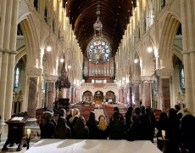
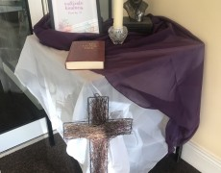
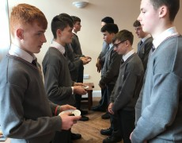
PBST took an active role in ensuring that CSW was celebrated in a meaningful and inclusive manner in all schools. This year’s theme was Catholic Schools – Communities of Faith and Resilience, a theme that was well chosen for such a challenging year in our schools. Large PBST-designed banners for display on external schools walls and railings have been provided to all PBST schools to promote Catholic Schools Week. As always, schools had access to extensive high-quality materials provided by the Catholic Schools Partnership.

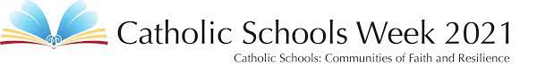

Special Education Needs:


Over the last five years, the Board of Directors has made it something of a singular mission to promote education for children with special needs in our schools. In particular, we have encouraged Boards of Management to set up Special Classes for children with Autistic Spectrum Disorder (ASD) or Downs Syndrome diagnoses. While this has been something of a slow-burner, it is very encouraging that three of our schools will have Special Classes in operation this coming September (including one at second-level), with firm commitments from at least two other second-level schools to establish classes as part of future building projects. The Board of Directors has been firmly of the view that a situation where families with a child with an ASD diagnosis who required Special Class provision often had to send that child to a different school from his or her siblings was something of an affront to the core values of a Presentation education.

Spirit of Pres Week:
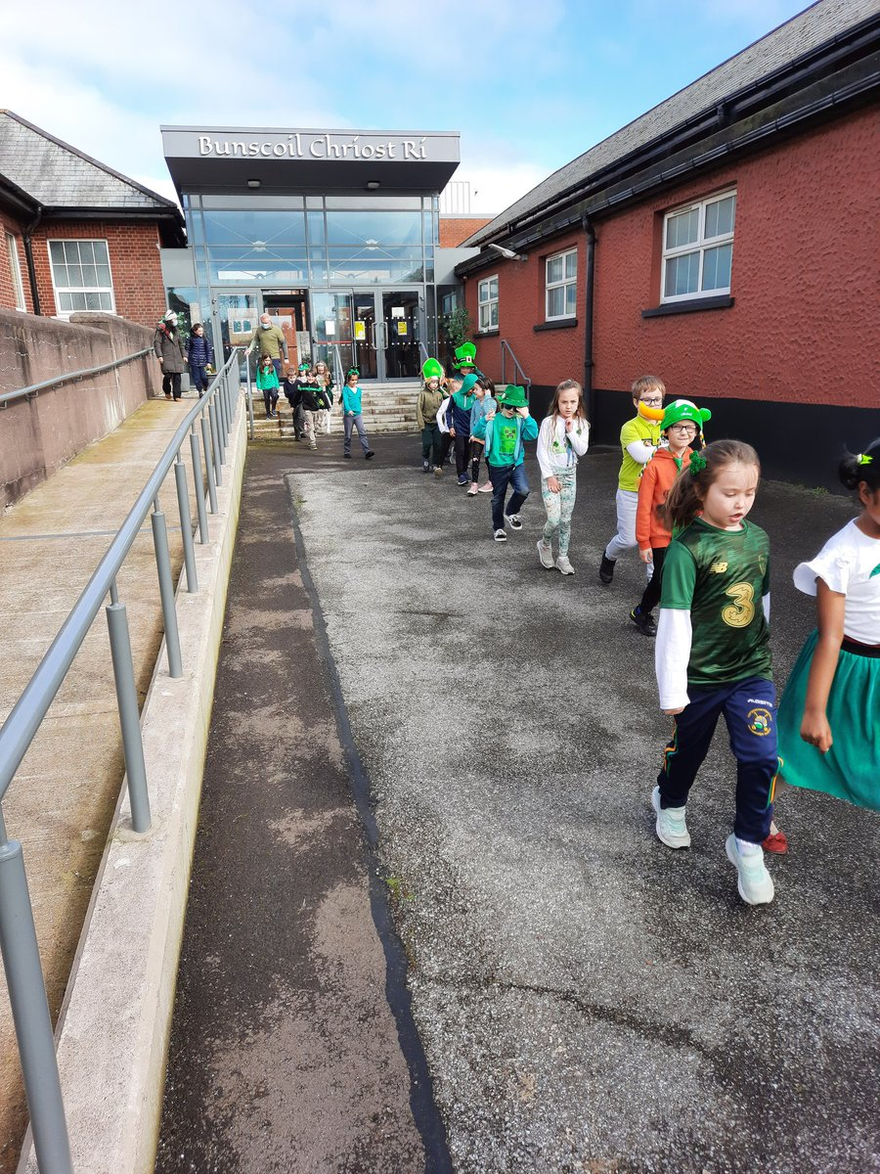

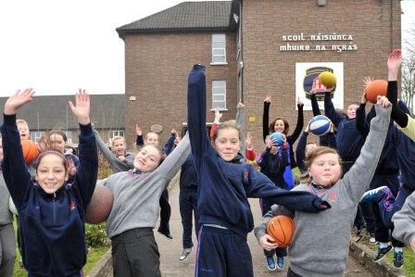
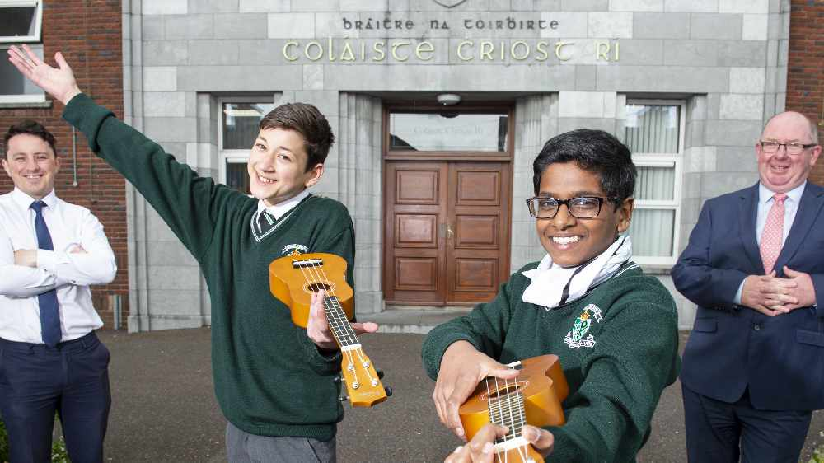

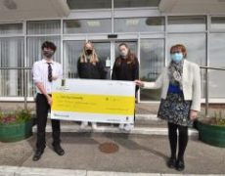
In November, schools marked the Feast of the Presentation of Our Lady by holding various events throughout the week of the Feast to celebrate and raise awareness of the characteristic spirit of PBST schools. This year’s celebrations were necessarily rather low-key compared to previous years but all schools made great efforts to mark the feast day as best they could.
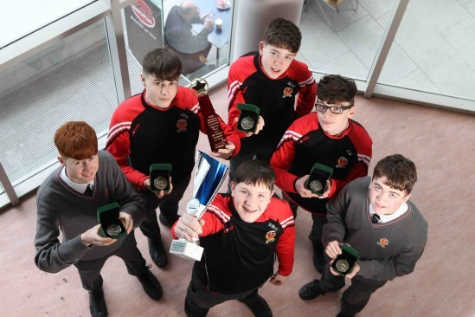


Association of Patrons and Trustees of Catholic Schools (APTCS)
PBST takes an active role as a Member of the newly-established Association of Patrons and Trustees of Catholic Schools with the CEO serving as a board member and as Chairperson of the Finance Committee. The Association (which was formerly known as the Association of Trustees of Catholic Schools) has recently been constituted as a registered charity and as a Company Limited by Guarantee under the direction of the Catholic Education Services Trust and has the newly-established Catholic Education Partnership as its sole legal member. This change is part of a more general reorganisation of Catholic education structures which also involves the Association of Managers of Catholic Secondary Schools (AMCSS) and will, in time, also include the Catholic Primary School Managers Association (CPMSA). It is hoped that the new structures will provide a coherence and an authoritative voice for Catholic education that was, perhaps, somewhat lacking in recent years. An executive office is currently being set up to promote trustee and patron interests, with Eilis Humphreys taking up the position of CEO on the 1st September 2021. PBST has agreed to contribute €4,500 per annum towards the running costs of the executive office. The Association has a wide remit and will offer valuable support to patrons and trustees on issues such as admissions, property, governance, statutory obligations, dealing with the DES and so on. The PBST CEO occupies one of the two places reserved on the board of directors for the mid-sized trust group comprised of the Presentation Brothers Schools Trust, the Loreto Education Trust, the Spiritan Education Trust, the Society of Jesus, and the Religious Sisters of Charity.
Association of Patrons and Trustees of Catholic Schools

Public Juridic Person (PJP)

PBST is one of a small group of trusts recognised by decree of the Irish Episcopal Conference as ecclesiastical Public Juridic Persons – defined as ‘members of Christ’s faithful authorised to carry out apostolic works in the name of the Catholic Church’. Two representatives of the four PJPs are entitled to places on the Board of the Catholic Education Service Committee (CESC). CESC may be seen as the ‘top level’ committee in Catholic education and is superior to the Catholic Education Partnership mentioned above. By agreement with PBST and ERST, the two places are currently occupied by CEIST and Le Cheile but, following each meeting, an online briefing is organised to keep the other trusts informed. As the two places will rotate to PBST and ERST later this year, PBST will have to nominate a representative to serve alongside an ERST nominee on the CESC Board. This nominee will have to be a serving Member of PBST (and not a director or officer of the trust).

Report to Irish Episcopal Conference (IEC):
As per Clauses 30 and 31 of the Canonical Statues of PBST, the Annual Report of the activities of the Foundation and a copy of the Annual Audited accounts were submitted to the IEC. Carmel Murphy (Chairperson) and Michael Sexton (CEO) met with Bishops Brendan Kelly and Francis Duffy and with Fr Paul O’Connell (representatives of the IEC) via Zoom on 17th May. The meeting provided a forum for an interesting discussion on governance and finance/investments as well as on the respective roles of the patron and trust in relation to the primary schools.

Meeting with Bishop Fintan Gavin:
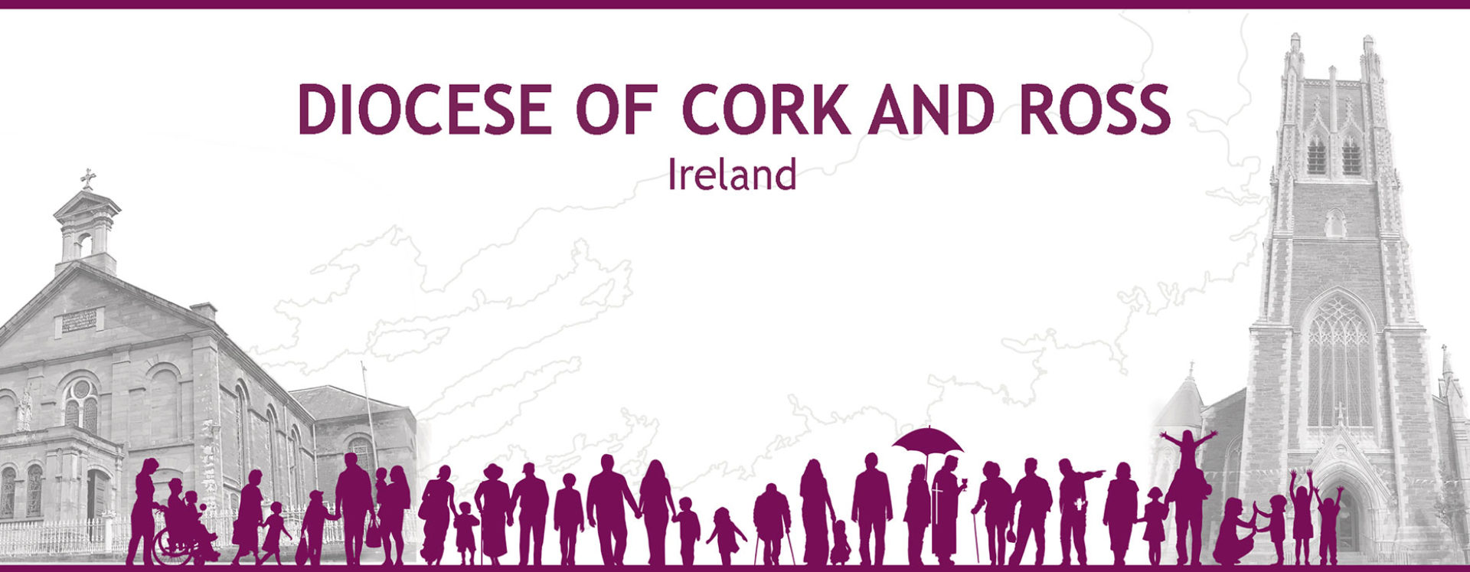
Carmel Murphy (Chairperson), TJ Coakley (Director) and Michael Sexton (CEO) met with Bishop Fintan at the diocesan offices on the 19th May. This meeting (which had been requested by the trust) provided PBST with an opportunity to update the Bishop on the current work of the trust and to clarify our understanding of the new Bishop’s wishes with regard to our role in the primary schools under his patronage. Bishop Gavin was already very well informed about the trust and was extremely encouraging of our efforts to promote Catholic education in the six PBST schools in the Cork and Ross diocese. In particular, he was very supportive of our role in providing an added level of financial oversight in the three primary schools. The trust representatives took the opportunity to make known to Bishop Gavin PBST’s willingness to become the patron of any new school that might be established under Catholic patronage in the diocese in the coming years.

DES School Inspections:
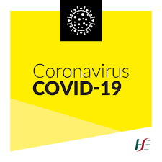
Safe Provision of Schooling (Covid-19) inspections were carried out in all the trust’s second-level schools (with the sole exception of Colaiste Chríost Rí) during the course of the year. In all cases, the schools were found to be totally compliant with the regulations. Letters acknowledging the success of these inspections were issued to the Boards of Management of each of these schools. Copies of inspection reports in primary schools are not provided to the trust by the DES but are instead made available to the Diocesan authorities (as Patron).

Trusteeship and patronage generally:
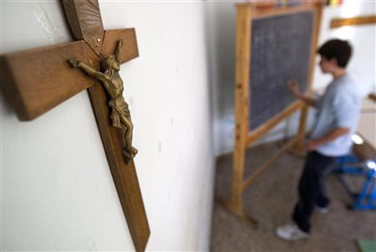
Consideration was given by the Board in October to submitting an application for the patronage of the new second-level school to be built in Ballincollig. Information was, however, received that the diocesan authorities would not welcome an application from PBST as the Bishop had already given his approval to an application by the Le Chéile schools trust. Two rival applications from Catholic trusts would, naturally enough, undermine each other’s chances of success. While this news was disappointing, it did, perhaps, demonstrate a certain naivety on our part in presuming that the canvassing process would begin only when the applications were submitted. Clearly, much groundwork would need to be done in advance of any future application. We have also alerted the Bishop to our willingness to take on the patronage of any future Catholic second-level schools in the Cork and Ross diocese and that, in view of our being the only trust based in Cork and our having a long-established and well respected ‘brand’, we should be the ‘trust of first choice’ in the diocese when new Catholic patronage is being considered.

A preliminary enquiry was made earlier in the year by representatives of a group of schools (that are not currently part of a trust group) run by a religious congregation. This involved the congregation’s education authority entering into an arrangement with PBST for the provision of ‘trustee services’ and entailed the supply of services to support the schools’ ethos (but would not have involved ownership of properties). The Board of PBST were hesitant about the idea but did not dismiss it out of hand. A polite letter of reply was issued but there has been no further follow-up. An informal enquiry was received from the Principal of a ‘regular’ Catholic Primary School in the city which is currently under the patronage of the Bishop about whether his school might become part of the PBST network where, he felt, his school might be better supported in promoting its Catholic ethos. The principal was advised by the trust that this would be a highly unusual move and that, even in the event that PBST were open to the idea, the diocese might be reluctant to set a precedent by divesting itself of its patronage/trusteeship function.
A discussion also took place with Department of Education officials (at their request) concerning the patronage of second-level Special Schools that have yet to be built. The DES interest seemed to focus particularly on the potential of the trust to provide suitable sites for such a school rather than on the issue of the patronage of the schools. Current DES thinking seems to favour the setting up of Special Schools on existing school campuses rather than on stand-alone sites, as this would facilitate the integration of some students into mainstream education for some lessons. While the DES appeared extremely keen to engage with us at one point during the year, we have heard nothing in several months.

Summary

The 2020-21 year has been another which has been greatly affected by Covid-19. Along with the well-publicised disruption to in-school learning, many of the trust’s activities that focus on ethos development of staff and students had to be curtailed. The greater part of the trust’s interactions with schools and even the meetings of the board of directors moved to on-line platforms. Notwithstanding these difficulties, it was, overall, a successful and certainly very busy year. As noted in last year’s report, more and more of the directors’ time is being taken up with compliance of one type or another. Charities, like schools, are now becoming increasingly regulated and it seems likely that this trend will continue, placing onerous demands on trustees who act in a voluntary capacity. The departure of TJ Coakley and Pat Coffey from the Board will leave a void, not merely of experience and expertise but also, of wisdom and good humour. The outgoing board not only accomplished a lot but also laughed a lot. The four remaining directors look forward to welcoming two new directors following their anticipated appointment at the forthcoming Annual General Meeting. The Board also extends its best wishes to the two outgoing Members, Gene Murphy and Fergal O’Gara, and acknowledges their many years of service to PBST. They will be greatly missed.
We hope that the coming year will see, if not an end to the pandemic, at least an end to its capacity to affect our work with our school communities. We look forward to a number of exciting projects including the possibility of an EU-sponsored Erasmus Plus programme at Easter 2023 where, if our application is successful, we will have an opportunity to travel to Italy as an extended PBST community of Directors, Members, Board of Management Chairpersons, Principals and Deputy Principals to explore the challenges of delivering faith-based education in a modern, highly secularised European society. We also take this opportunity to thank Dr Margaret O’Donovan for her tireless work in conducting the recently-completed company review (all the more challenging given that it was conducted over a much longer time period than had originally been envisaged). Based on her findings, we can now look forward to devising and implementing a new strategic plan to guide the work of the trust over the coming five years. Finally, we thank all in our school communities and beyond who have contributed so much in these difficult times to further the development of Presentation education. It is truly our privilege to be associated with such wonderful people.

Outgoing Members and Directors



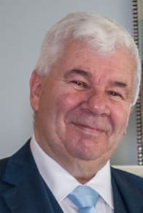


Mr Gene Murphy Mr Fergal O’Gara Mr TJ Coakley Mr Pat Coffey
Member Member Director Director

We remember


We pray for the repose of the soul of young Jimmy Horgan, a 1st Year pupil in Presentation Brothers College, who was tragically killed in a road traffic accident near the school in November.

Signed (on behalf of the Board of Directors):

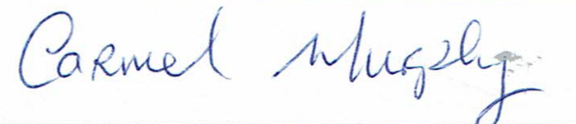
_____________________________ Date: 20th August 2021
Ms Carmel Murphy (Chairperson)

Directors: Carmel Murphy (Chairperson), T.J Coakley, Pat Coffey, Anna Herrick, Pat Hegarty. Colm Ó Corcora
Secretary: Michael Sexton
Co. Reg. No.: 466013 – a company limited by guarantee not having a share capital.
Registered Charity No. 20071721 CHY 18608

