ETERNAL LIFE
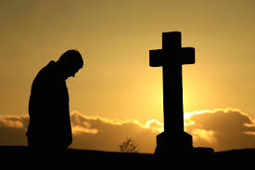
God’s basic gift to each one of us is existence in a love relationship with Him and with one another now and forever. It is a complex gift with varied stages and surprises, with joys and sorrows, with hopes and fears, with failures, sorrows and forgiveness. Unique to each of us but the common certainty is that God never takes back His gift. We may be unaware of the gift at times, or even choose deliberately to ignore it, but He is always moulding us to live through love in His presence. In this process, there are decisive transition moments and because they are so central we surround them with rituals to alert us again and again to their significance.
So this weekend, we have a double celebration of the one reality, eternal love and life. Sunday, as the Feast of All Saints, is a recognition that each of us is a unique work of God’s art and is fashioned to be a saint, that is to live in unconditional never ending love with Him and with one another forever.
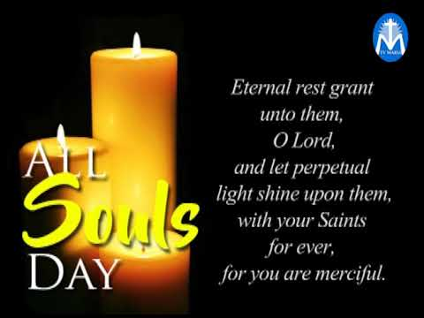
Monday, as the Feast of All Souls, seems to me to highlight a human anxiety that many of us share, that our loved ones that have gone before us may not have got everything quite in order when the final call came and we want to help them on their way.
One way or the other, we remember them before God in grateful love and by our novena prayer. Be assured, they remember us, as we ask protection in this COVID 19 time. “Think of the love that the Father has lavished on us by letting us be called God’s children and that is what we are.” John 3: 1-3

Reflection provided by Fr Tom Clancy
Dennehy’s Cross Parish, Cork.

