2022-2023

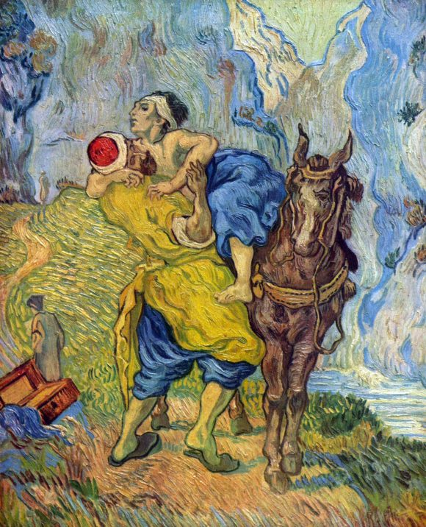
Liturgical Calendar
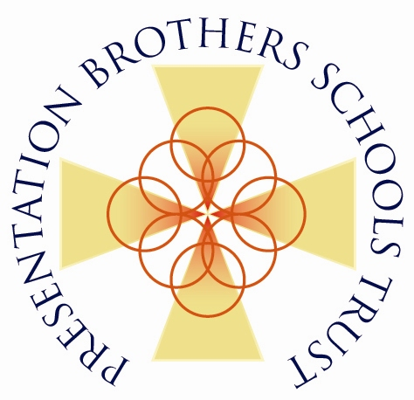
Good Samaritan by Vincent Van Gogh

The Good Samaritan parable eloquently presents the basic decision we need to make in order to rebuild our wounded world. In the face of so much pain and suffering, our only course is to imitate the Good Samaritan. Any other decision would make us either one of the robbers or one of those who walked by without showing compassion for the sufferings of the man on the roadside.
The parable shows us how a community can be rebuilt by men and women who identify with the vulnerability of others, who reject the creation of a society of exclusion, and act instead as neighbours, lifting up and rehabilitating the fallen for the sake of the common good.
Pope Francis. Fratelli Tutti P67

This calendar has been produced in co-operation with the Spiritan Education Trust
and the Association of Patrons and Trustees of Catholic Schools (APTCS)
SEPTEMBER 2022
Mon | Tue | Wed | Thu | Fri | Sat | Sun
29 | 30 | 31 | 1 | 2 | 3 | 4
 |  |  | - World Day of Prayer for the Care of Creation  - Season of Creation begins, and ends on October 4 |  | Anniversary of the death of Alan Kurdi 2015 (a 3-year-old boy found dead on a Turkish beach)
5 | 6 | 7 | 8 | 9 | 10 | 11
 |  |  | - International Literacy Day  - Feast of the Birth of Blessed Virgin Mary | - Feast of Blessed Jacques Laval C.S.Sp.  - Hajj (Annual Pilgrimage to Mecca, Islamic) | Hajj (Annual Pilgrimage to Mecca, Islamic) | Hajj (Annual Pilgrimage to Mecca, Islamic)
12 | 13 | 14 | 15 | 16 | 17 | 18
Hajj (Annual Pilgrimage to Mecca, Islamic) | Hajj (Annual Pilgrimage to Mecca, Islamic) | - Hajj (Annual Pilgrimage to Mecca, Islamic)  - Eid-al-Adha (Festival of Sacrifice, Islamic), begins at sundown | UN International Day of Democracy | UN International Day for the Preservation of the Ozone Layer
19 | 20 | 21 | 22 | 23 | 24 | 25
 |  | UN International Day of Peace | World Car Free day |  |  | Rosh Hashanah (Jewish), begins at sundown
26 | 27 | 28 | 29 | 30 | 1 | 2
 | Feast Day of St. Vincent de Paul |  | Feast of St. Michael the Archangel

OCTOBER 2022
Mon | Tue |  |  | Wed | Thu |  | Fri |  | Sat |  | Sun
26 | 27 |  |  | 28 | 29 |  | 30 |  | 1 |  | 2
 |  |  |  |  |  |  |  |  | - Feast Day of St. Theresa of Lisieux, Patroness of Missions  - International Day of Older Persons |  | - Feast Day of Claude Poullart des Places, Spiritan Founder  - International Day of Nonviolence – Mohandas Gandhi’s birthday
3 | 4 |  |  | 5 | 6 |  | 7 |  | 8 |  | 9
 | - Feast Day of St. Francis of Assisi, Patron of Environment  - Yom Kippur (Jewish), begins at sundown |  |  | International World Teacher’s Day |  |  |  |  |  |  | Sukkoth (Jewish Feast of Tabernacles)
10 | 11 |  |  | 12 | 13 |  | 14 |  | 15 |  | 16
- Sukkoth (Jewish Feast of Tabernacles)  - World Mental Health Day | Sukkoth (Jewish Feast of Tabernacles) |  |  | Sukkoth (Jewish Feast of Tabernacles) | Sukkoth (Jewish Feast of Tabernacles) |  | Sukkoth (Jewish Feast of Tabernacles) |  | Sukkoth (Jewish Feast of Tabernacles) |  | - Sukkoth (Jewish Feast of Tabernacles)  - UN. World Food Day
17 | 18 |  |  | 19 | 20 |  | 21 |  | 22 |  | 23
International Day for the Eradication of Poverty | EU Anti-Trafficking Day |  |  |  |  |  |  |  |  |  | World Mission Sunday
24 | 25 |  |  | 26 | 27 |  | 28 |  | 29 |  | 30
- United Nations Day
- Diwali – the Hindu Festival of Lights
31 | 1 |  |  | 2 | 3 |  | 4 |  | 5 |  | 6
NOVEMBER 2022
Mon |  | Tue | Wed |  |  | Thu |  | Fri |  | Sat |  | Sun
31 |  | 1 | 2 |  |  | 3 |  | 4 |  | 5 |  | 6
 |  | All Saints Day | All Souls Day
7 |  | 8 | 9 |  |  | 10 |  | 11 |  | 12 |  | 13
 |  |  |  |  |  |  |  |  |  |  |  | World Day of the Poor (Vatican)
14 |  | 15 | 16 |  |  | 17 |  | 18 |  | 19 |  | 20
Feast Day of St. Lawrence O’Toole, Patron Saint of Dublin |  |  | International Day of Tolerance |  |  |  |  |  |  |  |  | - Feast of Christ the King  - Universal Children’s Day
21 |  | 22 | 23 |  |  | 24 |  | 25 |  | 26 |  | 27
The Presentation of the Blessed Virgin Mary  PRES DAY |  |  |  |  |  | - Thanksgiving Day  - Evangeli Gaudium, The Joy of the Gospel (2013), Pope Francis |  | UN Day for Elimination of Violence against Women |  |  |  | 1st Sunday of Advent
28 |  | 29 | 30 |  |  | 1 |  | 2 |  | 3 |  | 4

DECEMBER 2022
Mon | Tue | Wed | Thu | Fri | Sat | Sun
28 | 29 | 30 | 1 | 2 | 3 | 4
 |  |  | World AIDS Day | UN Day for the Abolition of Slavery | - Feast Day of St. Francis Xavier, Patron of Missions  - UN day for Disabled Persons | 2nd Sunday of Advent
5 | 6 | 7 | 8 | 9 | 10 | 11
UN day celebrating Volunteering | Feast Day of St. Nicholas |  | Feast of the Immaculate Conception |  | UN Human Rights Day | 3rd Sunday of Advent (Joyous Sunday)
12 | 13 | 14 | 15 | 16 | 17 | 18
 |  | Feast Day of St. John of the Cross |  |  | Birthday of Pope Francis (1936) | 4th Sunday of Advent
19 | 20 | 21 | 22 | 23 | 24 | 25
 | International Human Solidarity Day | Winter Solstice |  |  |  | - Christmas  - Deus Caritas Est, God is Love (2005) Pope Benedict XVI
26 | 27 | 28 | 29 | 30 | 31 | 1
Feast Day of St. Stephen, first martyr | Feast Day of St. John, apostle and evangelist |  |  |  | New Year’s Eve

JANUARY 2023
Mon | Tue | Wed | Thu | Fri | Sat | Sun
26 | 27 | 28 | 29 | 30 | 31 | 1
- New Year’s Day
- World Day of Peace (Vatican)
- Solemnity of Mary, Mother of God
2 | 3 | 4 | 5 | 6 | 7 | 8
 |  |  |  | Feast of the Epiphany
9 | 10 | 11 | 12 | 13 | 14 | 15
Baptism of the Lord |  |  | Anniversary of the Haitian earthquake that killed 200,000 and left 2.3m homeless
16 | 17 | 18 | 19 | 20 | 21 | 22
Martin Luther King, Jr. Day |  | Week of Prayer for Christian Unity, finishes 25th
23 | 24 | 25 | 26 | 27 | 28 | 29
 |  |  |  | International Day of Commemoration of the Holocaust (UN) | Chinese New Year (Confucian/Daoist/Buddhist) (Year of the Rabbit) | - World Day of Leprosy  - Catholic Schools Week starts
30 | 31 | 1 | 2 | 3 | 4 | 5
FEBRUARY 2023
Mon | Tue | Wed | Thu | Fri | Sat | Sun
30 | 31 | 1 | 2 | 3 | 4 | 5
 |  | Feast Day of St. Bridget | - Feast Day of St. Blaise, Patron of throat illnesses  - Feast Day of Francis Libermann, Spiritan Founder |  | - World Cancer Awareness Day  - Catholic Schools Week ends  - Birthday of Rosa Parks (1913-2005) African American civil rights leader
6 | 7 | 8 | 9 | 10 | 11 | 12
- Feast of our Lady of Lourdes
- World Day of Prayer for the Sick
13 | 14 | 15 | 16 | 17 | 18 | 19
 | Feast of St. Valentine
20 | 21 | 22 | 23 | 24 | 25 | 26
UN World Day of Social Justice | Pancake Tuesday - Mardi Gras | Ash Wednesday |  |  |  | 1st Sunday of Lent
27 | 28 | 1 | 2 | 3 | 4 | 5
 | Feast Day of Blessed Daniel Brottier C.S.Sp.

MARCH 2023
Mon | Tue | Wed | Thu | Fri | Sat | Sun
27 | 28 | 1 | 2 | 3 | 4 | 5
 |  | International Day for the Abolition of the Death Penalty |  |  |  | 2nd Sunday of Lent
6 | 7 | 8 | 9 | 10 | 11 | 12
 |  | International Women’s Day |  |  |  | 3rd Sunday of Lent
13 | 14 | 15 | 16 | 17 | 18 | 19
 |  |  |  | Feast Day of St. Patrick |  | - Feast Day of St. Joseph  - 4th Sunday of Lent
20 | 21 | 22 | 23 | 24 | 25 | 26
 | UN Day for the Elimination of Racial Discrimination | - World Water Day  - Ramadan (Muslim observance) begins at sundown and continues for 30 days |  | Feast Day for St. Oscar Romero and anniversary of his assassination | Feast Day of the Annunciation | - Anniversary of the Abolition of Trans-Atlantic Slave Trade (UN)  - 5th Sunday of Lent
27 | 28 | 29 | 30 | 31 | 1 | 2

APRIL 2023
Mon | Tue | Wed | Thu | Fri | Sat | Sun
27 | 27 | 29 | 30 | 31 | 1 | 2
- Anniversary of the death of Saint Pope John Paul II (1920-2005)
- Palm Sunday
3 | 4 | 5 | 6 | 7 | 8 | 9
 |  |  | Holy Thursday of the Lord’s Supper | - UN World Health Day  - Good Friday | - Easter Vigil  - Amoris Laetitia (The Joy of Love) 2016 Pope Francis | Easter Sunday
10 | 11 | 12 | 13 | 14 | 15 | 16
 |  | International Day for Street Children
17 | 18 | 19 | 20 | 21 | 22 | 23
 |  |  |  | Eid al-Fitr - Ramadan ends at sundown | Earth Day
24 | 25 | 26 | 27 | 28 | 29 | 30
 |  |  |  |  | Feast of St. Catherine of Siena, “Be who God meant you to be and you will set the world on fire.”

MAY 2023
Mon | Tue | Wed | Thu | Fri | Sat | Sun
1 | 2 | 3 | 4 | 5 | 6 | 7
St. Joseph the Worker |  |  |  | Feast Day of Blessed Edmund Rice
8 | 9 | 10 | 11 | 12 | 13 | 14
World Red Cross and Red Crescent Day
15 | 16 | 17 | 18 | 19 | 20 | 21
- International Conscientious Objectors’ Day  - UN Day of Families |  |  | - International Communications Day (Vatican)  - Feast of the Ascension | Novena to the Holy Spirit |  | UN Day for Dialogue and Development
22 | 23 | 24 | 25 | 26 | 27 | 28
 | Laudato Si Celebration week | - Laudato Si Celebration week  - Laudato Si, On Care for our Common Home (2015) Pope Francis | - Laudato Si Celebration week  - Shavuot, Jewish festival commemorates the giving of the Torah at Mount Sinai | Laudato Si Celebration week | Laudato Si Celebration week | - Laudato Si Celebration week  - Feast of Pentecost
29 | 30 | 31 | 1 | 2 | 3 | 4
- Laudato Si Celebration week  - International Day of United Nations Peacekeepers | Laudato Si Celebration week | Feast of the Visitation of Mary

JUNE 2023
Mon | Tue | Wed | Thu | Fri | Sat | Sun
29 | 30 | 31 | 1 | 2 | 3 | 4
- UN Day of Innocent Children, Victims of Aggression
- Feast of the Holy Trinity
5 | 6 | 7 | 8 | 9 | 10 | 11
World Environment Day |  |  |  |  |  | Feast of Corpus Christi
12 | 13 | 14 | 15 | 16 | 17 | 18
World Day against Child Labour |  |  |  |  | UN Day to Combat Desertification and Drought
19 | 20 | 21 | 22 | 23 | 24 | 25
 | World Refugee Day | Summer solstice
26 | 27 | 28 | 29 | 30 | 1 | 2
UN Day in Support of Victims of Torture |  |  | Caritas in Veritate, Charity in Truth (2009) Pope Benedict XVI

JULY 2023
Mon | Tue | Wed | Thu | Fri | Sat | Sun
26 | 27 | 28 | 29 | 30 | 1 | 2
3 | 4 | 5 | 6 | 7 | 8 | 9
10 | 11 | 12 | 13 | 14 | 15 | 16
 | Anniversary of Srebrenica Slaughter in Bosnia (1995) | Birthday of Malala Yousafzai, Pakistani activist for female education and youngest-ever Noble Prize Laureate
17 | 18 | 19 | 20 | 21 | 22 | 23
 | Nelson Mandela International Day |  |  |  | Feast of Mary of Magdala – Apostle to the Apostles
24 | 25 | 26 | 27 | 28 | 29 | 30
 |  |  |  |  | Lumen Fidei, The light of Faith (2013) Pope Francis | International Day of Friendship
31 | 1 | 2 | 3 | 4 | 5 | 6
Feast Day of St. Ignatius of Loyola

AUGUST 2023
Mon | Tue | Wed | Thu | Fri | Sat | Sun
31 | 1 | 2 | 3 | 4 | 5 | 6
 | World Youth Day 2023, Portugal | World Youth Day 2023, Portugal | World Youth Day 2023, Portugal | World Youth Day 2023, Portugal | World Youth Day 2023, Portugal | - World Youth Day 2023, Portugal  - Anniversary of the bombing of Hiroshima (1945)
7 | 8 | 9 | 10 | 11 | 12 | 13
- Anniversary of the bombing of Nagasaki (1945)
- International Day of the World’s Indigenous Peoples
14 | 15 | 16 | 17 | 18 | 19 | 20
Feast Day of Maximilian Kolbe, priest and martyr | Feast Day of the Assumption of Mary |  |  |  | World Humanitarian Day
21 | 22 | 23 | 24 | 25 | 26 | 27
 |  | International Day for the Remembrance of Slave Trade and Its Abolition |  |  | Birthday of Saint Mother Teresa of Calcutta (1910-1997)
28 | 29 | 30 | 31 | 1 | 2 | 3
Martin Luther King, Jr., delivered his I Have a Dream speech, Washington, D.C. (1963) |  | Islamic New Year

