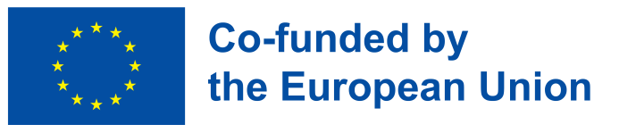

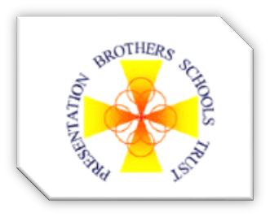
Erasmus+ PBST Trip to Malta


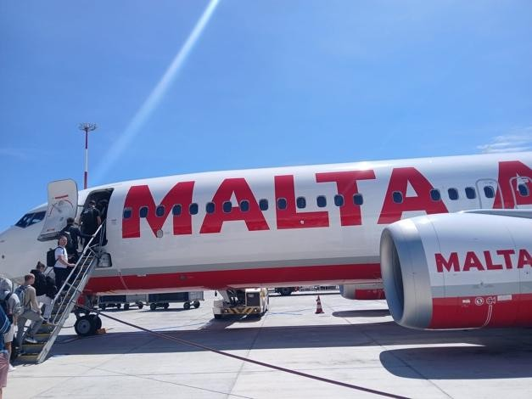
Erasmus+ is the EU’s programme that assists and supports education, training, youth and sport. the programme provides opportunities for teachers to promote transnational learning by taking groups to other eu countries and allowing them to experience different cultures.

IN THE FRAMEWORK OF its Erasmus+ accreditation (2022-1-IE01-KA120-SCH-000093521), PBST chose to take part in this experience to help broaden teachers’ outlooks and assist them in improving their teaching in support of their students’ learning needs.

The goal of the trip was to allow the teachers to reflect on their current views about inclusion of migrants in our schools and having learned about the maltese experience, to see if there are any learnings that they might apply in the irish context on their return home.

April 2025 mobility

The main objective of this project was to provide insights into how different educational systems work in assimilating migrant children, thus encouraging teachers to adopt a more open approach when promoting inclusion and diversity.

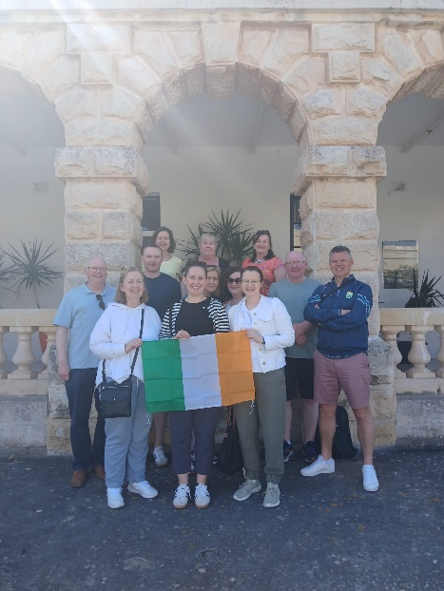
the participants attended a structured learning programme where they were given an overview of the education system in malta and of the curriculum taught in the local schools. they were also presented with the main principles of the Content Language Integrated Learning technique and shown why activating content and language is important.

Another aim was to increase knowledge of practical strategies to promote inclusion in the classroom. This encourages the teachers to design a more migrant-friendly curriculum and help foster an inclusive environment.

Funded by the European Union. Views and opinions expressed are however those of the author(s) only and do not necessarily reflect those of the European Union or the European Education and Culture Executive Agency (EACEA). Neither the European Union nor EACEA can be held responsible for them.

Outcomes and Impact

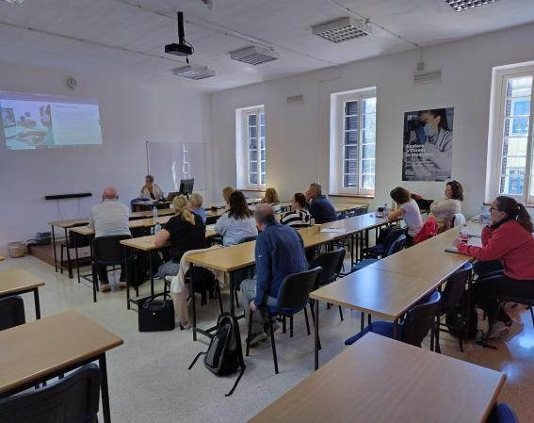
The various activities in which the teachers engaged allowed them gain a much broader view on cultural diversity and demonstrated how racism in the classroom can have a huge impact on migrant and refugee students.

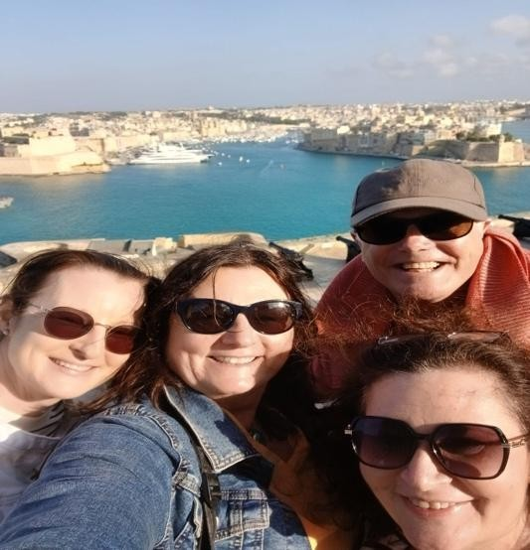
Participation in the Erasmus + programme has provided a great opportunity for the participating teachers to develop skills to help combat discriminatio and promote the integration of migrant students both educationally and socially. it also enabled them to reflect on any personal biases they may have had prior to participation.

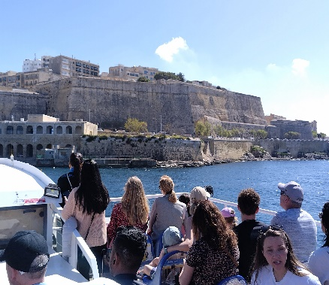
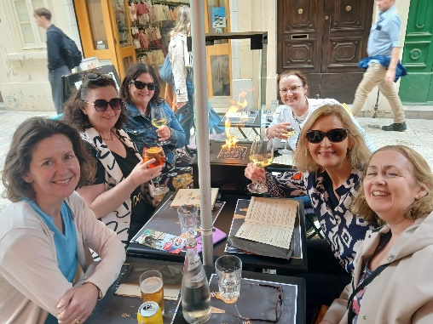
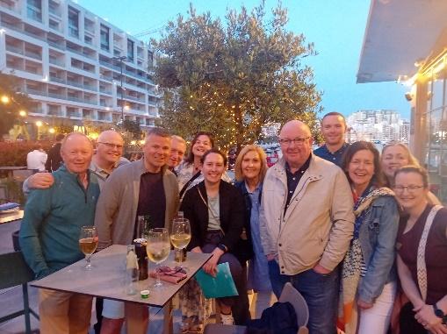
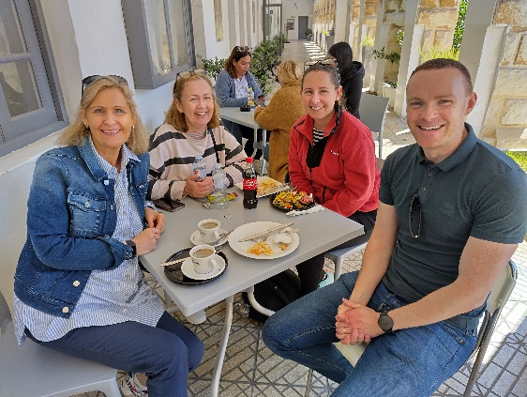
This may have a major impact on the way teachers go about dealing with situations relating to these issues and will allow them to keep an open mindset when faced with sensitive cultural issues.
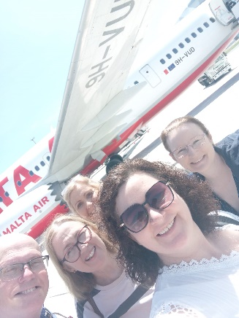
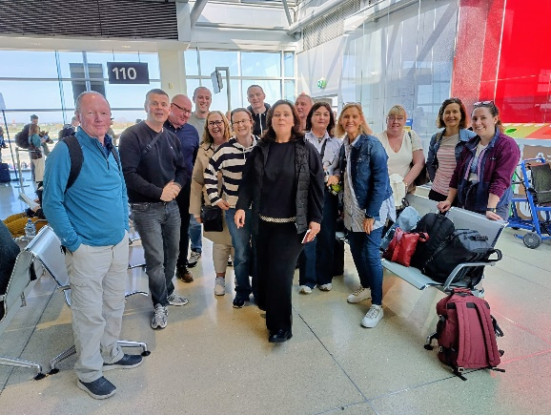

Funded by the European Union. Views and opinions expressed are however those of the author(s) only and do not necessarily reflect those of the European Union or the European Education and Culture Executive Agency (EACEA). Neither the European Union nor EACEA can be held responsible for them.

